Robert Skelton

MATLAB Project 4

11.13.12

Code

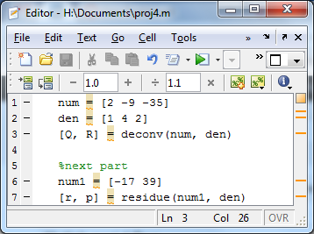

Output:

